Chapter 7, Problem 59.

Determine the step response v_{o}(t) to v_{s} = 18 u(t) V in the circuit of Fig. 7.124.

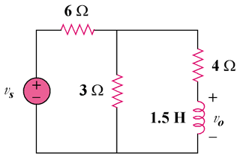

Figure 7.124
For Prob. 7.59.

